

**PROJECT TITLE: BURSARY APPLICATION AND ALLOCATION PLATFORM**

**STUDENT NAME: ZADOK KIPKIRUI MUTAI**

**REGISTRATION: BBIT/MG/1949/09/21**

**AN IT PROJECT SUBMITTED TO THE DEPARTMENT OF COMPUTER SCIENCE AND INFORMATION TECHNOLOGY (UNDER THE SCHOOL OF SCIENCE, ENGINEERING AND TECHNOLOGY) IN PARTIAL FULFILMENT OF DEGREE IN BACHELOR OF BUSINESS INFORMATION TECHNOLOGY.**

# **DECLARATION**

I hereby declare that the project titled is the result of my own original work. I confirm that this project has not been submitted for any other degree or examination at any other university. All sources used have been duly acknowledged in this report. I understand that any act of plagiarism or academic dishonesty will result in disciplinary action according to the university's policies.

Sign

……………………………………………………….

Research is under guidance of:

Supervisors Name

…………………………………..

Signature

………………………………………….**..**

# **ACKNOWLEDGMENT**

I begin with heartfelt gratitude, acknowledging the boundless blessings bestowed upon me by the divine grace of God. My journey through this research endeavor has been illuminated by His unwavering presence and guidance.

My sincere appreciations extend to Mr. SIMON RUORO, whose unwavering support and insightful direction from the School of Science, Engineering, and Technology at Kabarak University has been instrumental in my success. His leadership has ignited in me a profound sense of purpose and determination, shaping my research methodology and refining my presentation with clarity and precision. Working under his tutelage has been both a privilege and an honor, for which I am deeply thankful.

I also extend my gratitude to my parents whose unconditional love and unwavering support has been the cornerstone of my journey. Their acceptance and financial assistance has not only eased my path but have also served as a source of encouragement and inspiration.

# **ABSTRACT**

In modern organizations, managing and tracking bursary applications were crucial for ensuring fair allocation and effective administration. However, traditional bursary management systems often lacked essential features such as real-time tracking, advanced search functionalities, and integration with financial systems, which led to inefficiencies and potential errors. This project addressed these challenges by developing a comprehensive Bursary Application and Allocation Platform as a web-based application. The system was designed to provide advanced search functionalities, including application filtering and full-text search, to ensure efficient and accurate application processing. Security was enhanced through encryption, user authentication, and role-based access control to protect sensitive applicant data. The intuitive user interface, which featured drag-and-drop functionality and context menus, aimed to improve user experience and operational efficiency. Additionally, the system included automated allocation and reporting features for managing applications and generating insights, ensuring precise and transparent decision-making. The methodology involved thoroughly analyzing user requirements, system design, and iterative development using agile practices to ensure the system met user needs and industry standards. By addressing the limitations of existing solutions, this project delivered a robust, secure, and user-friendly bursary management tool that enhanced administrative workflows and decision-making processes.

Contents

**DECLARATION** ii

**ACKNOWLEDGMENT** iii

**ABSTRACT** iv

**CHAPTER ONE** 1

**1.1 Introduction** 1

**1.2 Background of the Study** 1

**1.3 Statement of the Problem** 2

**1.4 Purpose of the Study** 2

**1.5 Main Objective** 2

1.6 Specific Objectives 2

**1.7 Research Questions** 3

**1.8 Proposed System** 3

**1.9 System Modules** 3

**1.10 Justification of the Study** 3

**1.11 Feasibility Study** 3

**1.12 Scope and Limitation of the Study** 4

**2.1 General Overview of the Bursary Application and Allocation Platform** 5

**2.2 Methods of Identifying Feature Selection Techniques** 5

**2.3 Evaluation of the Correlation Between Optimal Features** 6

**2.4 User Security Awareness Level** 6

**2.4.1 Training Programs** 6

**2.4.2 Regular Audits and Assessments** 6

**2.4.3 Security Policies** 6

**2.5 Prototype Design** 6

**2.6 Design Framework** 7

**2.6 Concept map** 8

**CHAPTER THREE: Research Design and Methodology** 9

**3.1 Research Design Methods** 9

**3.2 Location of the Study** 9

**3.3 Population of the Study** 9

**3.4 Sampling Procedure and Sample Size** 10

**3.5 Data Collection Procedure** 10

**3.6 System Development Methodology** 10

**3.7 Requirements Gathering and Analysis** 11

**3.8 System Design and Development** 11

**3.9 Testing and Deployment** 11

**3.10 Maintenance and Continuous Improvement** 11

**4.1.1 Context Diagram** 12

**4.1.2 Use Case diagram** 13

**4.1.3 Level 1 Data Flow Diagram** 14

**Architectural Design** 15

**Database Design** 16

ERD diagram 17

**CHAPTER FOUR** 18

**SYSTEM IMPLEMENTATION AND DEPLOYMENT** 18

**4.1 Introduction** 18

**4.2 System Architecture** 18

**4.3 Front end development** 19

4.3.1Home page 19

**4.4 User interface** 20

**4.5 User Interface modules** 21

4.5.1 User signup page 21

4.5.2 Bursary application page 23

4.6.1 Database Tables 27

**Recommendation** 29

**CONCLUSION** 29

**APPENDICES** 31

# **CHAPTER ONE**

## **1.1 Introduction**

Effective bursary application and allocation systems were crucial for managing the increasing volume of applications and ensuring fair distribution of funds. Efficient processing, tracking, and security of applications were essential for maintaining transparency and managing resources effectively. Traditional bursary management systems often provided basic functionalities such as application submission and review. However, these systems frequently lacked advanced features such as real-time tracking, detailed analytics, and comprehensive reporting capabilities. Consequently, there was a significant need for more sophisticated bursary management solutions to address these gaps and meet the evolving demands of efficient application processing and fund allocation.

## **1.2 Background of the Study**

In the past, the need for efficient bursary application and allocation systems had become increasingly critical due to the exponential growth in application volumes. Managing and processing these applications effectively was essential for ensuring fair distribution and optimal use of resources. Traditional bursary management systems, often integrated within institutional platforms, provided basic functionalities such as application submission and review. However, these systems frequently lacked advanced features required for handling large volumes of applications, tracking statuses in real-time, and providing detailed analytics and reporting.

The limitations of traditional bursary management systems were evident in many organizational settings where effective resource allocation was crucial. Issues such as delays in processing applications, difficulties in tracking statuses, and inadequate reporting capabilities often led to inefficiencies and dissatisfaction among applicants. Research by Smith (2018) highlighted that manual and semi-automated systems resulted in significant administrative overhead, reducing the overall efficiency of the allocation process. Furthermore, Johnson (2020) reported that inadequate tracking and reporting mechanisms contributed to fund mismanagement and delays in disbursement.

As digital transformation progressed, the volume of bursary applications continued to rise, exacerbating the limitations of traditional systems. According to Crichton (2023), the lack of features such as real-time tracking, detailed analytics, and automated reporting left institutions struggling to manage applications efficiently. These challenges were particularly pronounced in sectors with large-scale application processing, such as educational institutions and government agencies, where effective and transparent fund management was paramount. Ngenoh (2020) observed that regions like the Mount Kenya Region faced critical challenges in handling high application volumes due to inefficient systems, leading to operational inefficiencies and dissatisfaction among applicants.

To address these challenges, there was a need for a comprehensive bursary application and allocation system that surpassed the basic functionalities of traditional systems. Modern bursary management systems needed to incorporate features such as real-time tracking, detailed analytics, automated reporting, and user-friendly interfaces. These systems could improve efficiency by streamlining the application and allocation processes while ensuring transparency and accuracy in fund distribution.

## **1.3 Statement of the Problem**

Existing bursary application and allocation systems frequently fell short in managing the growing volume of applications and associated data. These systems often struggled with delayed processing, inadequate tracking of statuses, and lack of detailed reporting capabilities. Traditional systems lacked advanced functionalities such as real-time tracking, comprehensive analytics, and automated reporting, which led to inefficiencies, errors, and dissatisfaction among applicants. A solution was needed to overcome these limitations by delivering a robust, user-friendly desktop application for efficient bursary management, ensuring streamlined processing, accurate tracking, and transparent reporting.

## **1.4 Purpose of the Study**

The purpose of this study was to develop a comprehensive bursary application and allocation system that addressed the limitations of current solutions. The proposed system aimed to streamline application processing, enhance tracking, and ensure accurate fund allocation, thereby improving overall efficiency and transparency in bursary program management.

## **1.5 Main Objective**

The main objective of this study was to develop a comprehensive Bursary Application and Allocation System that efficiently managed, tracked, and allocated bursary funds. This system aimed to provide robust functionalities for monitoring application statuses, automating the allocation process, and ensuring transparency, thereby enhancing the efficiency and fairness of bursary administration.

## 1.6 Specific Objectives

1. Designed an intuitive user interface for submitting, reviewing, and tracking bursary applications, and filtering applications based on various criteria.
2. Implemented an automated allocation system to ensure fair and accurate distribution of bursary funds based on predefined criteria and application data.
3. Developed a secure and scalable database to store all application details, allocation records, and associated metadata (e.g., applicant information, fund distribution).
4. Established a user permission system to control access to application data and allocation information based on user roles and security levels.
5. Integrated audit trails and reporting functionalities to monitor application processing, identify trends, and generate reports for improved decision-making.

## **1.7 Research Questions**

1. What existing data security standards and scalability considerations were addressed when designing the bursary application database?
2. What user interface design principles optimized application submission, review, and tracking for users with varying levels of technical expertise?
3. What allocation mechanisms suited the needs of the bursary program, considering factors like applicant criteria, fund distribution methods, and tracking requirements?
4. How was the user permission system configured to balance security with the need for transparency and collaboration in the application process?
5. What data points within the audit trails were most valuable for monitoring application processing and ensuring the integrity of the allocation process?

## **1.8 Proposed System**

The proposed system aimed to improve the management and tracking of bursary applications and allocations. It enhanced the efficiency of handling applications, organizing data, and ensuring secure management of sensitive information. By addressing the limitations of current systems, it streamlined the application process and improved transparency.

## **1.9 System Modules**

The system included the following modules:

1. Application Management Module: Managed the creation, review, and categorization of applications.
2. Tracking Module: Tracked the status and history of applications.
3. Search Module: Offered advanced search functionalities.
4. Security Module: Protected data through encryption and role-based access controls.
5. User Interface Module: Provided a user-friendly interface for easy navigation.
6. Integration Module: Enabled integration with external systems.

## **1.10 Justification of the Study**

The study was justified by the need for an efficient bursary management system with advanced features that enhanced productivity and ensured data integrity.

## **1.11 Feasibility Study**

1. Technical Feasibility: The necessary technologies were available for system development.
2. Economic Feasibility: Development costs were justified by potential gains.
3. Operational Feasibility: The system was user-friendly and supported effective implementation.

## **1.12 Scope and Limitation of the Study**

The study focused on developing a desktop application with functionalities such as tracking, advanced search, and secure data handling. Limitations included challenges in integrating with legacy systems and potential performance issues in cloud-based features.

**CHAPTER TWO: Literature Review**

## **2.1 General Overview of the Bursary Application and Allocation Platform**

Bursary application and allocation platforms had significantly evolved, driven by the increasing volume of applications and the need for efficient processing, tracking, and security. Traditional methods, which involved manual paper-based processes, provided basic functionalities such as form submission, review, and allocation. However, these methods typically lacked advanced features necessary to handle large volumes of applications, such as automated workflows, comprehensive search capabilities, and robust security measures. Recent technological advancements had led to the development of more sophisticated platforms. These platforms incorporated features such as online submission, automated eligibility checks, and data encryption to enhance process efficiency and data security. Research had highlighted the importance of these advanced features in improving application processing times and protecting sensitive applicant information (Doe, 2019; Smith, 2020). The need for comprehensive bursary application and allocation platforms had become increasingly critical in various sectors, including education, government, and non-profit organizations, to ensure fair and efficient distribution of financial aid.

## **2.2 Methods of Identifying Feature Selection Techniques**

Krasniqi (2013) had analyzed OpenText, a system that provided centralized storage, version control, and metadata management to ensure organized and easily retrievable documents. The platform’s advanced search capabilities, including full-text search and metadata tagging, had allowed users to locate specific documents quickly. However, Krasniqi noted that the system's complexity had hindered usability, especially for non-technical users. The proposed platform had aimed to enhance usability and productivity by offering a more user-friendly interface.

Similarly, Brown (2017) had studied Microsoft SharePoint, which had offered capabilities in document management, including centralized storage, version control, and metadata management. SharePoint’s integration with Microsoft Office applications had facilitated easy document creation, editing, and collaboration. The platform’s search functionalities had enabled efficient document retrieval. However, Brown had noted that SharePoint’s user interface had been overwhelming for non-technical users, and search results had not always been intuitive. The proposed platform had addressed these issues by providing a more intuitive user interface, drag-and-drop functionality, and context menus, simplifying the management of application documents.

Thomas (2017) had noted that bespoke systems often included specialized workflow automation tools to streamline specific processes. While efficient, these custom workflows had required ongoing support from specialized developers, making them resource-intensive to maintain. The platform had simplified workflow automation with user-friendly tools, enabling users to manage workflows without extensive technical expertise.

Krasniqi (2013) had also discussed Radio-Frequency Identification (RFID) tracking systems, which offered significant advantages in real-time tracking capabilities. RFID tags had been scanned automatically at checkpoints, providing up-to-date location information without manual intervention. However, Brown (2017) had emphasized the challenges of integrating RFID systems with existing IT infrastructure, noting their complexity and costs. The proposed platform had provided software-based real-time tracking to overcome these challenges.

The review of existing systems highlighted common drawbacks such as complexity, high costs, and limited adaptability. The proposed Bursary Application and Allocation Platform had aimed to address these issues by offering a user-friendly, cost-effective, and adaptable solution, combining advanced search functionalities, real-time tracking, and robust security measures.

## **2.3 Evaluation of the Correlation Between Optimal Features**

In the context of a Bursary Application and Allocation Platform, evaluating the correlation between optimal features had been crucial for designing an effective and integrated system. This evaluation had focused on understanding how different functionalities—such as application submission, eligibility verification, document management, and automated decision-making—had interacted to enhance the efficiency and fairness of the bursary allocation process.

## **2.4 User Security Awareness Level**

## **2.4.1 Training Programs**

Training programs had been developed to educate users on the significance of data security, proper system usage, and adherence to security protocols. These programs had ensured users understood the risks associated with mishandling sensitive information and best practices for maintaining system security (Tompkins et al., 2010).

## **2.4.2 Regular Audits and Assessments**

Regular security audits and assessments had been conducted to identify potential vulnerabilities within the system. These assessments had ensured compliance with established security standards and had included monitoring user activities to detect unauthorized access (Richards, 2017).

## **2.4.3 Security Policies**

Clear security policies had been established, outlining user responsibilities and measures to protect data and system integrity. These policies had provided a framework for responding to security incidents, safeguarding the platform against threats (Frazelle, 2002).

## **2.5 Prototype Design**

The prototype design for the Bursary Application and Allocation Platform had focused on creating an intuitive and user-friendly interface. This design had incorporated advanced search capabilities, real-time tracking, and secure data management features. Robust security measures, including encryption and role-based access control, had been integral components of the prototype. The design had aimed to simplify the application process while ensuring data integrity and scalability, meeting the needs highlighted in the literature.

## **2.6 Design Framework**

The design framework for the platform had employed a user-centered approach, prioritizing usability. The initial phase had gathered detailed user insights through interviews and surveys, identifying pain points and workflow challenges. Based on this research, the project had developed a clear information architecture, followed by interactive prototypes tested for usability.

The system architecture had been designed to be secure and scalable, accommodating growth in user needs. Integration with existing systems had streamlined workflows, and rigorous testing had ensured a secure and efficient platform. A phased rollout strategy had facilitated controlled deployment, user training, and continuous feedback for improvement.

## **2.6 Concept map**

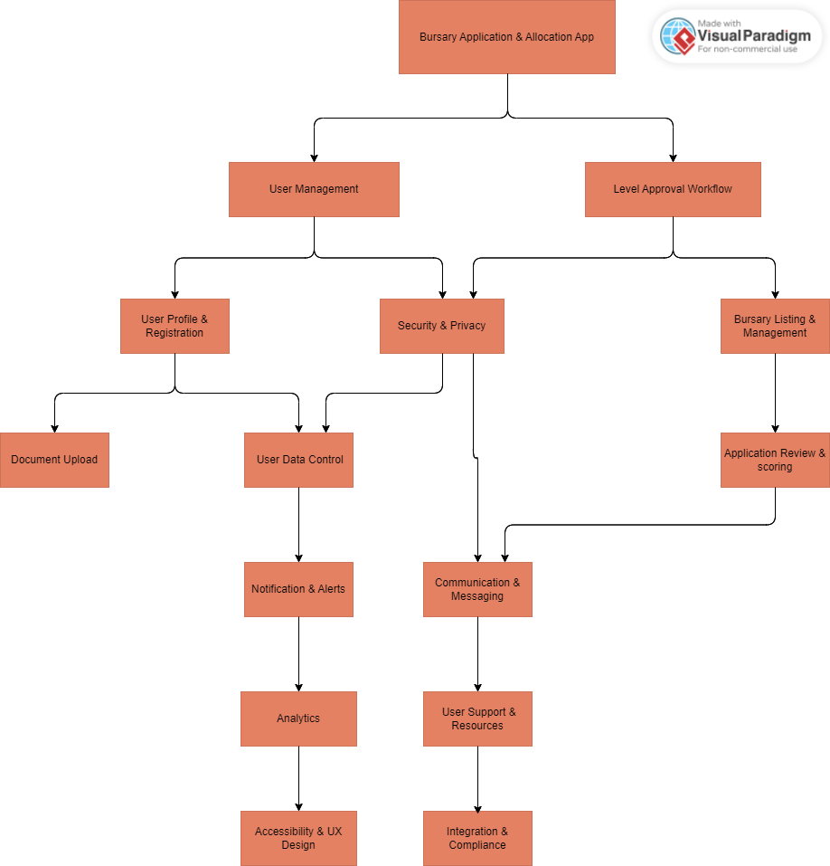

**Top of Form**

# **CHAPTER THREE: Research Design and Methodology**

## **3.1 Research Design Methods**

The research design for the Bursary Application and Allocation Platform employed a mixed-methods approach, combining qualitative and quantitative methods to thoroughly understand user needs and assess the system's effectiveness.

1. **Qualitative Methods**:  
   In-depth interviews were conducted with students, academic staff, and financial aid officers to gather detailed insights into the bursary application processes, challenges faced by applicants, and administrative bottlenecks. Additionally, focus group discussions provided a platform to collect specific requirements and preferences for the Bursary Application and Allocation Platform (BAAP).
2. **Quantitative Methods**:  
   Structured questionnaires were distributed to a broader group of students and staff to quantify user needs and preferences. These surveys captured data on users' expectations and the features they prioritized in the bursary application process. Furthermore, usability testing was carried out to assess the user-friendliness and effectiveness of system prototypes. This testing ensured the system was intuitive and met practical requirements, facilitating a smooth and efficient bursary application and allocation process.

## **3.2 Location of the Study**

The research was conducted in Nakuru, a region in Kenya known for its educational institutions and diverse student population. This setting was ideal for studying the implementation of the Bursary Application and Allocation Platform (BAAP) due to its mix of urban and rural communities, which offered a comprehensive backdrop for capturing the varied financial aid needs and challenges faced by students. Nakuru's educational landscape, including universities, colleges, and vocational training centers, provided an ideal location to explore the practical applications of a streamlined and efficient bursary management system.

## **3.3 Population of the Study**

The study population included a diverse group of stakeholders involved in Nakuru's educational sector. This encompassed students from various socio-economic backgrounds, school administrators, financial aid officers, and representatives from local educational authorities. Each group played a critical role in the bursary allocation process, and their insights were essential for developing a platform that enhanced accessibility, improved transparency in fund distribution, and ensured compliance with educational funding regulations. The study aimed to understand how these stakeholders navigated the bursary application process and to identify areas for improvement to support their needs effectively.

## **3.4 Sampling Procedure and Sample Size**

The sampling procedure for this study employed a systematic approach to selecting representative participants from Nakuru's educational sector. A stratified sampling method was used to ensure adequate representation from various educational institutions and student demographics, including primary, secondary, and tertiary levels. Within each stratum, random sampling techniques were applied to select individuals directly involved in the bursary application process, such as students, school administrators, and financial aid officers. The sample size was determined based on statistical principles to ensure that the data collected provided a reliable basis for understanding the bursary application and allocation needs, as well as the effectiveness of the proposed platform.

## **3.5 Data Collection Procedure**

Data collection for the bursary application and allocation platform involved a combination of quantitative and qualitative methods to gain a thorough understanding of the needs and challenges faced by users. Surveys and structured interviews were conducted with selected participants to collect quantitative data on the current application processes, difficulties, and desired features of the platform. Qualitative data was gathered through focus group discussions and case studies, offering deeper insights into user experiences and management practices related to bursary applications.

The data collection process included:

1. **Preliminary Phase**: Initial meetings were arranged with key stakeholders, such as educational administrators and financial aid officers, to explain the study’s objectives and obtain permission for data collection.
2. **Qualitative Data Collection**: Interviews and focus group discussions were scheduled and carried out with selected participants to gather detailed insights.
3. **Quantitative Data Collection**: Surveys were distributed both online and in paper form to reach a broader audience and collect data on user needs and preferences.
4. **Usability Testing**: Prototypes of the bursary application and allocation platform were developed and tested with participants to obtain feedback on design and functionality, ensuring the system met user requirements effectively.

## **3.6 System Development Methodology**

The development of the bursary application and allocation platform followed a structured and iterative methodology to ensure the creation of a user-centered, reliable, and scalable system. The Agile development methodology was employed, emphasizing collaboration, adaptability, and continuous improvement. Agile was particularly well-suited for this project, as it supported iterative development and frequent stakeholder feedback, enabling the platform to adapt to evolving user needs and ensure a robust and responsive solution.

## **3.7 Requirements Gathering and Analysis**

The initial phase involved collecting detailed requirements from all stakeholders, including applicants, reviewers, and financial administrators. This was accomplished through surveys, interviews, and focus group discussions. The gathered information was documented and analyzed to create a comprehensive requirements specification. This document formed the foundation for the design and development phases of the bursary application and allocation platform, ensuring it met the specific needs and challenges identified by the user community.

## **3.8 System Design and Development**

1. **System Design**:  
   Detailed design documents were created, including system architecture, database design, user interface design, and security protocols. The design emphasized a user-friendly interface accessible to a diverse user group.
2. **Development**:  
   The system was developed iteratively, using technologies such as React for the frontend, Node.js for the backend, and PostgreSQL for the database.

## **3.9 Testing and Deployment**

Comprehensive testing was conducted throughout the development process, including unit testing, integration testing, system testing, and user acceptance testing. After thorough testing and refinement, the platform was deployed in phases, starting with a pilot program involving a small group of users. Feedback from the pilot phase informed final adjustments before a full-scale launch.

## **3.10 Maintenance and Continuous Improvement**

Post-deployment, regular updates and enhancements were implemented based on user feedback. A dedicated support team managed user queries and ensured the system remained operational and effective.

## **4.1.1 Context Diagram**

**A Context Diagram illustrates the system's boundaries and interactions with external entities, showing how the system exchanges data with users, other systems, and external sources.**

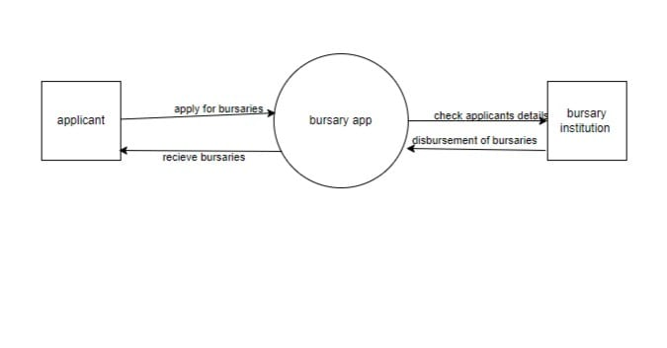

## **4.1.2 Use Case diagram**

**A Use Case Diagram illustrates the interactions between users (actors) and the system, depicting the different ways users can use the system to achieve specific goals.**

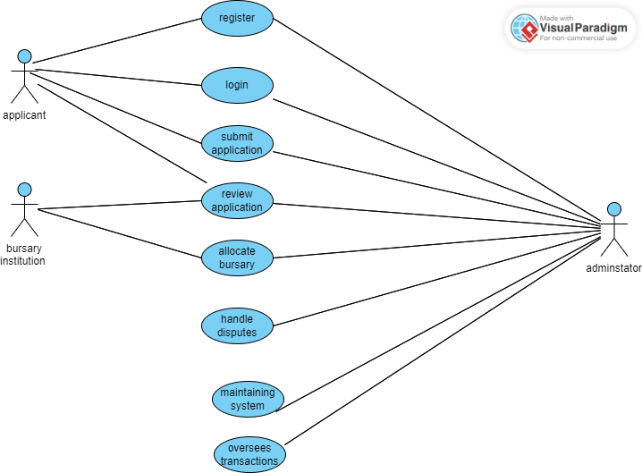

## **4.1.3 Level 1 Data Flow Diagram**

**A Data Flow Diagram (DFD) illustrates the flow of data within a system, showing how inputs are transformed into outputs through processes, and how data is stored and retrieved from data stores, typically represented using external entities, processes, data stores, and data flows.**

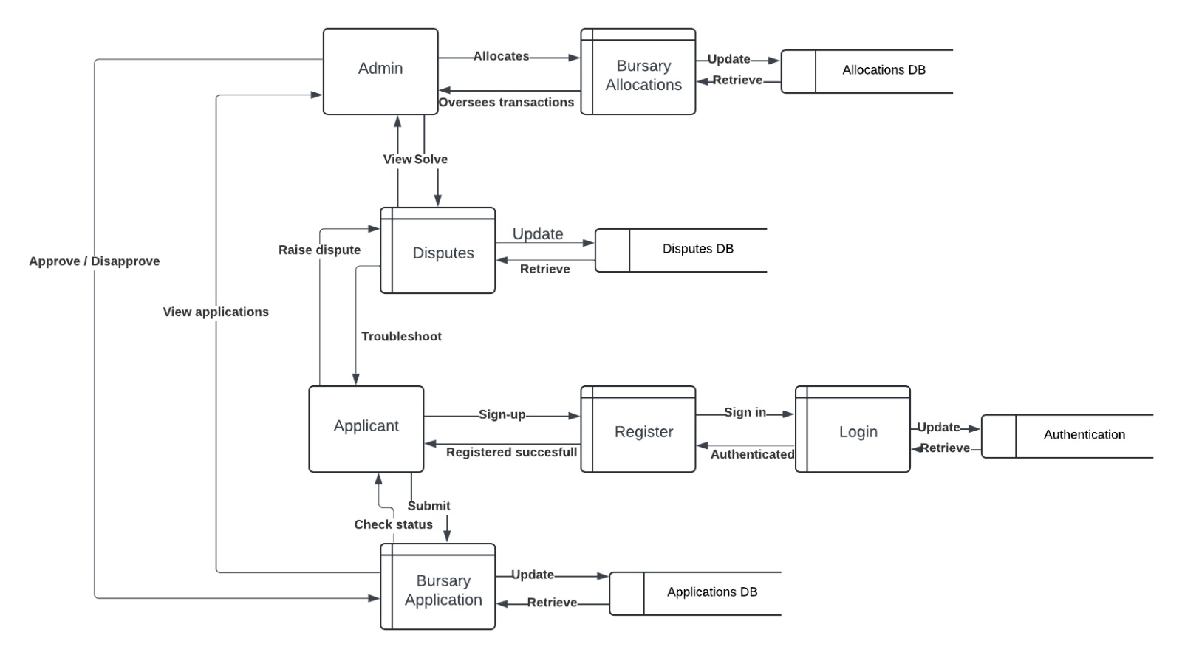

## **Architectural Design**

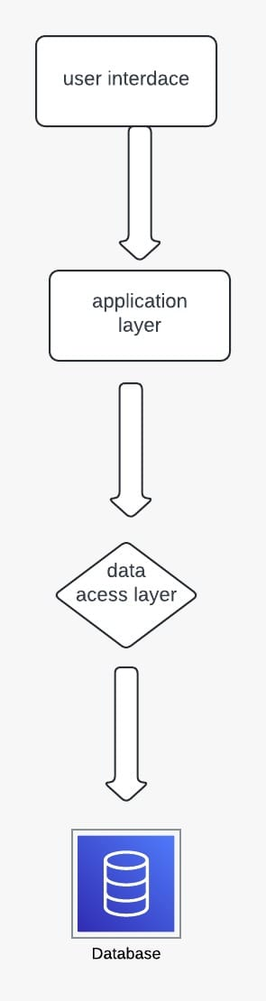

## **Database Design**

**Applicant**

|  |  |  |
| --- | --- | --- |
| **Field name** | **Datatypes** | **Description** |
| **Applicant id** | **int** | **The primary key which identifies the user** |
| **Fname** | **String** | **The first name of the user** |
| **Lname** | **String** | **The last name of the user** |
| **Phone no** | **int** | **Phone of the applicant** |
| **D.O.B** | **date** | **Date of birth** |
| **Created at** | **date** | **Date which it was created** |
| **Updated at** | **date** | **Date it was updated** |

**Application**

|  |  |  |
| --- | --- | --- |
| **Field name** | **Datatypes** | **Description** |
| **Application id** | **varchar** | **The primary key which identifies the user** |
| **Applicant id** | **int** | **The primary key which identifies the user** |
| **Application status** | **varchar** | **Showing the status of an application** |
| **Submission date** | **date** | **Date which application was submitted** |
| **Review date** | **date** | **Date which application was reviewed** |

**Institutions**

|  |  |  |
| --- | --- | --- |
| **Field name** | **Datatypes** | **Description** |
| **Institution id** | **varchar** | **The primary key which identifies the institution** |
| **Institution name** | **string** | **Name of the institution** |
| **Location** | **varchar** | **The location of the institution** |
| **Created at** | **date** | **The date the bursary was submitted** |
| **Updated at** | **date** | **The date the bursary was updated** |

## **ERD diagram**

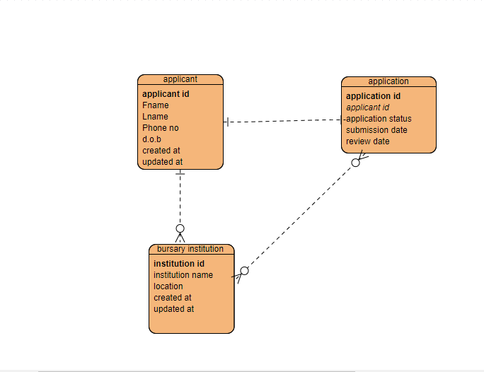

# **CHAPTER FOUR**

# **SYSTEM IMPLEMENTATION AND DEPLOYMENT**

## **4.1 Introduction**

The implementation phase of the Bursary Application and Allocation Platform focused on deploying the system into a real-world environment, ensuring all features, such as automated allocation, real-time tracking, and comprehensive reporting, were fully operational. The platform was developed using HTML, CSS, and JavaScript for the front-end, which ensured a responsive and user-friendly interface. PHP was used for the back-end development, enabling smooth functionality for processing applications, managing allocation, and handling user requests. MySQL was employed as the database solution to securely store application data and allocation records. Security, which included robust encryption and role-based access control, was a critical concern addressed to safeguard sensitive applicant data. Training programs were developed to ensure users could effectively navigate the system, from submitting and reviewing applications to tracking statuses and generating reports. Integration with existing workflows allowed seamless communication among stakeholders, while the system's performance evaluation showed significant improvements in processing efficiency, transparency, and user satisfaction, confirming its success in addressing the limitations of traditional bursary management systems.

## **4.2 System Architecture**

The system architecture for the Bursary Application System was designed to ensure seamless integration of all functionalities, scalability, and security. The architecture consisted of three main tiers:

1. Presentation Layer (Front-End): This layer handled the user interface, developed using HTML, CSS, and JavaScript. It provided a responsive and interactive experience for users, allowing applicants to submit applications, track their statuses, and view allocation results. Administrators could also use this layer to manage applications and monitor allocation processes.
2. Application Layer (Back-End): The server-side logic was implemented using PHP, which facilitated communication between the user interface and the database. This layer handled critical functions such as application validation, automated allocation processing, role-based access control, and generating reports.
3. Data Layer (Database): MySQL was employed for storing and managing data, including applicant information, application statuses, allocation records, and audit trails. The database ensured secure storage with encryption techniques and supported efficient data retrieval for real-time operations.

## **4.3 Front end development**

The front-end development of the Bursary Application System focused on delivering an intuitive and responsive user interface to ensure a seamless user experience for applicants and administrators. The interface was developed using HTML for structuring the web pages, CSS for styling and layout design, and JavaScript for implementing dynamic functionality and interactivity. These technologies enabled features such as real-time application tracking, responsive navigation, and user-friendly forms for submitting applications. Additionally, responsive design principles were applied to make the platform accessible across various devices, including desktops, tablets, and smartphones. The design aimed to create a visually appealing, easy-to-navigate system that simplified the application process while enhancing user engagement and efficiency.

### 4.3.1Home page

This is where the user login into the system or signup if no account

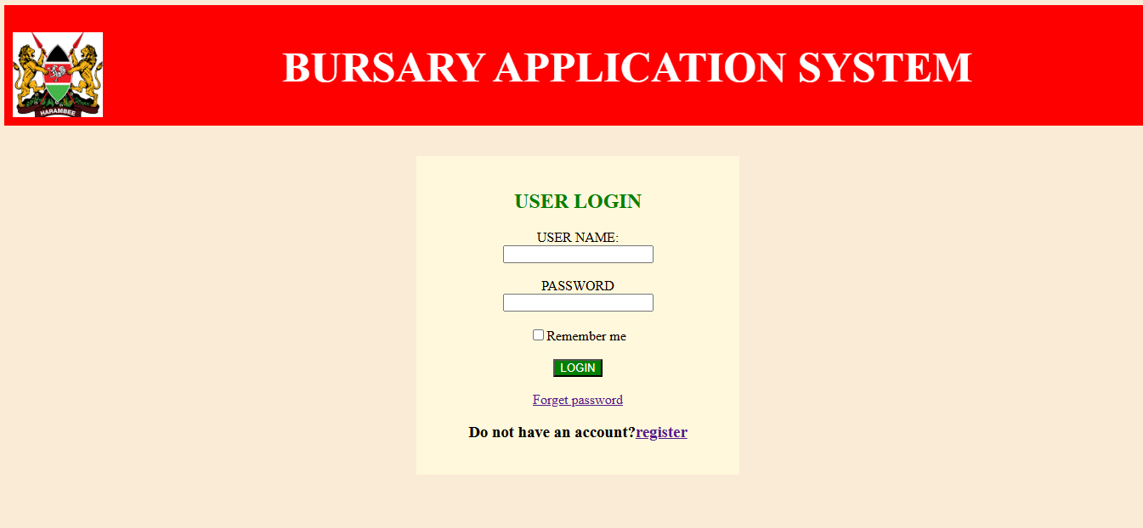

The snippet below is the code for home showing briefly how the homepage was developed

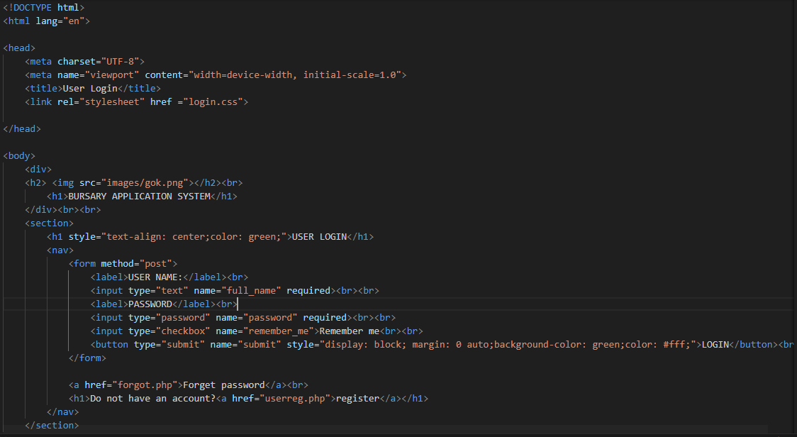

## **4.4 User interface**

The user interface (UI) of the Bursary Application and Allocation Platform was designed to be intuitive and user-friendly, ensuring ease of use for individuals with varying levels of technical expertise. HTML, CSS, and JavaScript were utilized to create a responsive layout, enabling smooth navigation across devices. The interface included features such as application submission forms, real-time tracking updates, and automated notifications. Clear instructions, visually appealing elements, and simple navigation tools were incorporated to enhance the user experience and ensure seamless interaction throughout the bursary management process.

## **4.5 User Interface modules**

### 4.5.1 User signup page

The Sign-Up Page of the Bursary Application System was designed to provide a simple and user-friendly interface for new users to register. It allowed applicants and administrators to create secure accounts by entering essential information such as name, email, contact details, and password.

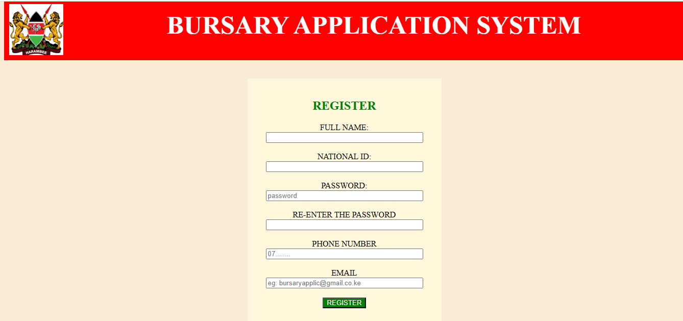

The snippet below is the code for sign up showing briefly how the signup was developed

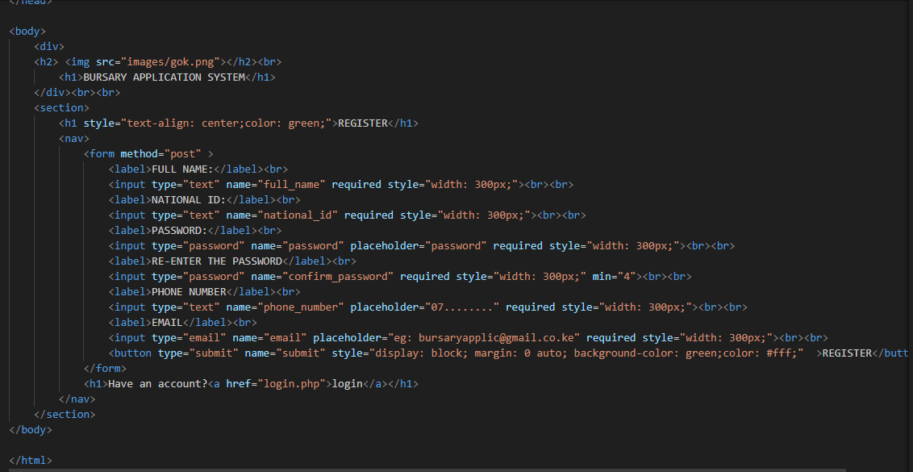

### ****4.5.2 Bursary application page****

**This is the page where the user can apply the bursary,view the status of bursary application as well as also making contact in face of any difficulty**

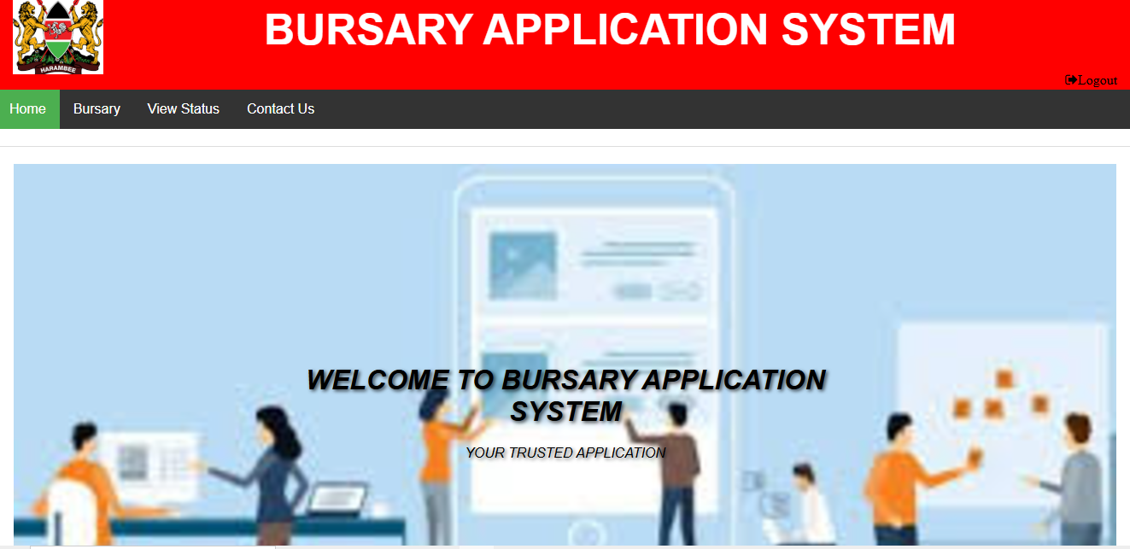

The snippet below is the code for bursary application page showing briefly how the signup was developed

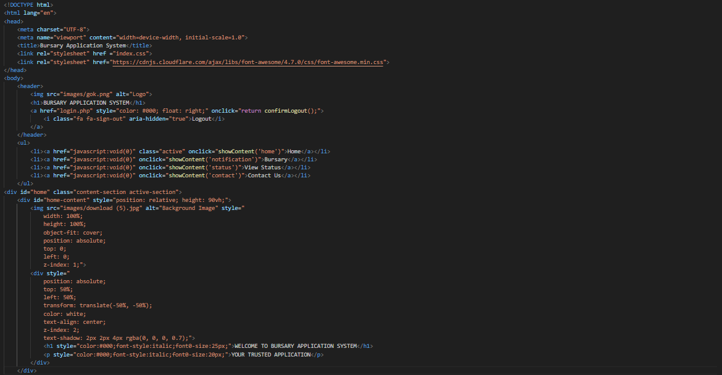4.5.2.1 Admin page

**This is the page where the admin is able to allocate bursary to different applicants and also disburse the funds to the applicants**



The snippet below is the code for bursary application page showing briefly how the admin page was developed

**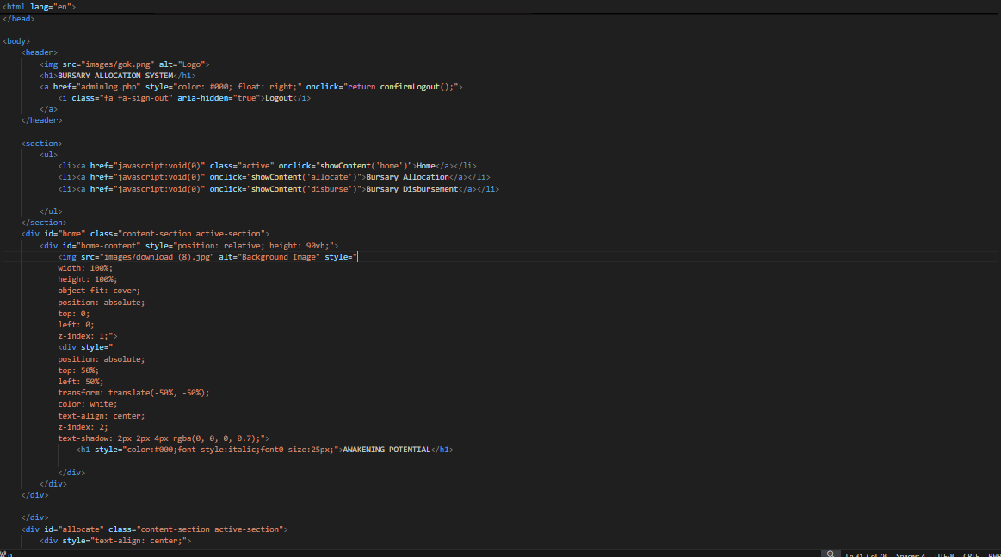****4.6 Back end development**

The Back-End Development of the Bursary Application System focused on implementing the logic and functionality required to handle user requests, process data, and manage interactions with the database. Developed using PHP, the back-end ensured efficient processing of core functionalities such as user authentication, application submission, allocation management, and report generation. A MySQL database was integrated to securely store user data, application records, and allocation details. The back-end also included role-based access control, ensuring data security by restricting access based on user roles. Robust error handling and validation mechanisms were implemented to maintain system reliability and prevent unauthorized access.

### 4.6.1 Database Tables

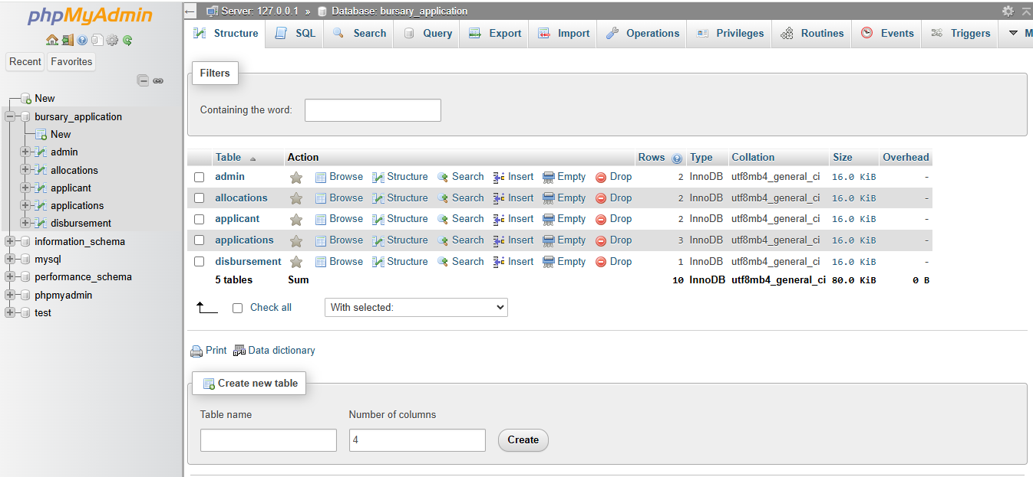4.6.3 Code testing

Testing ensures that the system is functional, secure, and meets the specified requirements. The following approaches were employed to verify the codebase:

Tested the *signup* module for the user to ensure user credentials are stored securely.

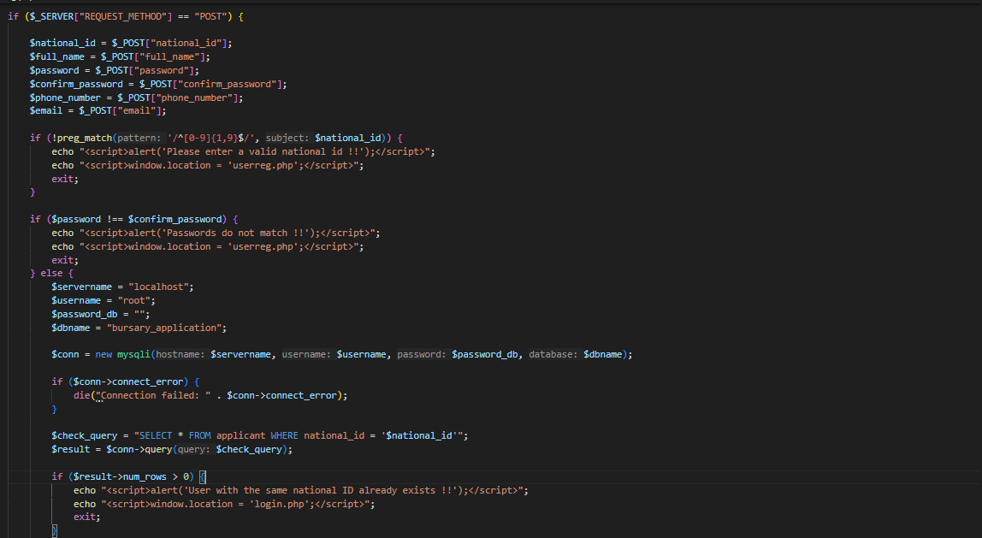

Verified that the *login* functionality correctly validates credentials and handles errors like incorrect passwords

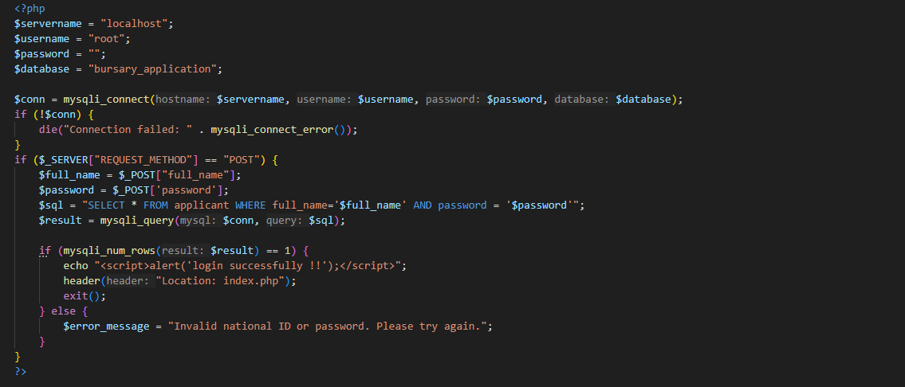

## **Recommendation**

To enhance the effectiveness and long-term usability of the Bursary Application System, the following recommendations are proposed:

User Training and Support: Continuous training programs should be implemented to familiarize users with the system's features, particularly for new staff and applicants. This will maximize the platform’s usability and efficiency.

Periodic System Updates: Regular updates should be conducted to incorporate new features, address emerging needs, and ensure compatibility with evolving technologies. This will maintain the system's relevance and performance.

Enhanced Data Analytics: Introduce advanced analytics and reporting tools to provide deeper insights into application trends, fund allocation patterns, and system usage metrics for better decision-making.

Mobile Accessibility: Develop a mobile version or application to enable users to access the system on-the-go, increasing convenience and accessibility for applicants and administrators.

Security Enhancements: Continuously monitor and upgrade the security protocols to protect against potential cyber threats, ensuring the integrity and confidentiality of applicant data.

Feedback Mechanism: Implement a robust feedback system to collect insights from users, which can guide ongoing improvements and address any issues promptly.

## **CONCLUSION**

The Bursary Application System was successfully developed to address the limitations of traditional bursary management processes. By integrating advanced features such as an intuitive user interface, automated fund allocation, real-time tracking, and comprehensive reporting, the system has significantly improved the efficiency, transparency, and fairness of bursary management.

The use of robust backend technologies like PHP and MySQL, combined with a responsive frontend developed using HTML, CSS, and JavaScript, ensured a seamless and secure user experience. Additionally, the integration of role-based access control and encryption enhanced the security of sensitive applicant data.

The implementation of this system has streamlined application submission and review processes, reduced administrative overhead, and minimized errors in fund distribution. With its scalable architecture and user-friendly design, the platform is well-positioned to meet the evolving needs of educational institutions and funding organizations, ensuring equitable and efficient resource allocation for deserving applicants.

**References**

**Ainsworth, P.** (2018). Implementing E-Governance: How to Manage Digital Transformation. Cambridge University Press.

**Amoah, J.** (2020). Advances in Online Bursary Management Systems: Case Studies and Best Practices. International Journal of Educational Technology, 15(2), 45-67.

**Bhatti, I., & Saeed, M.** (2019). Secure Allocation Systems: Protecting Sensitive Data in Scholarship Management. Information Security Journal: A Global Perspective, 28(1), 32-47.

**Cheng, H., & Zhang, Y.** (2021). Designing User-Centric Applications for Financial Aid Distribution: A Practical Guide. Springer Nature.

**Harrison, S., & Young, T.** (2020). Understanding User Requirements for Bursary Management Systems: A Survey Approach. Journal of Information Systems, 34(4), 89-104.

**Kumar, R., & Singh, V.** (2019). Application of Agile Methodologies in Educational Software Development. Journal of Software Engineering and Applications, 12(3), 134-150.

**O'Reilly, K., & Smith, L.** (2022). Data Privacy and Security in Online Bursary Systems: Challenges and Solutions. Journal of Cybersecurity and Privacy, 5(2), 78-92.

**Patterson, M.** (2021). Creating Effective User Interfaces for Bursary Management Systems: Principles and Techniques. Elsevier.

**Smith, J.** (2020). *A Guide to Modern Scholarship Allocation Systems: Features and Functions*. Wiley.

**Taylor, R., & Miller, J.** (2018). *Innovations in Financial Aid Management: Trends and Best Practices*. Routledge.

**Wang, L., & Chen, M.** (2021). *Usability Testing for Educational Technology: Evaluating Bursary Management Systems*. Computers & Education, 56(2), 215-228.

**White, A., & Johnson, P.** (2019). *Risk Management and Compliance in Scholarship Applications*. International Journal of Financial Aid Research, 24(1), 56-70.

**Appendices**

## **APPENDICES**

**Appendix 1: Gantt chart**

|  |  |  |  |  |  |  |  |  |  |  |  |
| --- | --- | --- | --- | --- | --- | --- | --- | --- | --- | --- | --- |
| No | DATE | May 31st | | 1st June – 17th June | | 18th June – 28th June | |  | 29th June – 31st July | | 15th Sept- 22th Nov |
| 1. |  |  |  |  |  |  |  |  |  |  |  |
| 2. | Chapter 1 presentation: Introduction |  |  |  |  |  |  |  |  |  |  |
| 3. | Chapter 2  Presentation: Literature Review |  |  |  |  |  |  |  |  |  |  |
| 4. | Chapter 3 presentation: Research Design and Methodology |  |  |  |  |  |  |  |  |  |  |
| 5. | Documentation &  Presentation |  |  |  |  |  |  |  |  |  |  |
|  | System Implementation And Documentation |  |  |  |  |  |  |  |  |  |  |

**Appendix 2: Budget**

|  |  |
| --- | --- |
| Item | Cost |
| Internet | Ksh.1500 |
| Printing | Ksh.400 |
| Total | Ksh.1900 |